ACKNOWLEDGEMENT

The merits of our project depends only on the wide panorama of the people who have devoted their precious time , and provided valuable suggestion as well as guidance to our project.

We are highly obliged to our H.O.D MAHESH GURUNANI SIR and our H.O.D MANISH SALVI SIR sir who passed our project at its very initial stage of planning. Also he told us to work on our project at the starting of the year. Also he told us to take the help of him if we want in our project.

We also express our gratitude towards our project guide VIKAS AGRAWAL SIR who has guided as well as helped from the apex of our project. We also express our gratitude to our project co-guide KIRAN SIR whose comments has greatly helped us to make our project more approachable towards the user.

We would also like to thanks our lab assistant who allowed to work on pc of their lab and also helped in our project for taking some printout. Also we thanks to their keen interest in our project and their intellectual assistance throughout their completion of their project.

The collection of the various ideas , and the progress of our project depends upon the intellectual of all the staff members of INFORMATION TECHNOLOGY AND COMPUTER ENGINEERING DEPARTMENTS.

Finally we would like to express our group members who have duly worked on the project and made it successful by the time of submission.

Affiliated to Maharashtra state board of technical education
(MSBTE) MUMBAI

C E R T I C A T E

This is to certify that
BHAVIN MISTRY.
SUJIT MOURYA.
CHINTAN RAMANANDI.
MIHIR JARIWALA.

Have submitted this project work entitled “Petrol Pump Management System” is a bonafied record of project work carried out in partial fulfillment for the award of the
DIPLOMA
IN
INFORMATION TECHNOLOGY

This is a record of their own work carried out by them under our supervision and
Guidance

---------------------------------------------
Project Guide
XYZ
---------------------- ---------------------------- H.O.D(I.F) PRINCIPAL
(xyz) (xyz)

2005-2006

PREFACE

Computerisation is worldwide and requires only software to run huge industries and institution. Today the industrial world is largely hit by automation.

Here we present our project of PETROL MANAGEMENT . The aim of our project is to acquaint our user with various detail of our system. Thus this report give you the brief overview of our project.

Our project report is divided into various chapter. In which the first chapter is introduction which gives the introduction about the whole project what the project is what is the main content of our project. The second chapter is about the system development life cycle means it gives us the information about how we had designed our project
.
The third chapter is about the language which we used in our project. And also the front-end language which we used in our project. The fourth chapter is about the DFD OF OUR PROJECT.

THE fifth chapter deals with the detail explanation of our project. It describes the various forms which we used in our project and what that forms means. The sixth and seventh chapter deals with the advantage and the application of our project.

Then eight chapter deals with future expansion of our project.

CONTENTS

CH.NO TOPIC P.N. 1 INTRODUDTION 6
1.1 Industries as the backbone
Of the country.
1.2 Current status of automation
In industries.
1.3 About Petrol Management.
1.4 Manual handling of the pumps.

2 PROJECT PLAN 9
2.1 Feasiblity study
2.1.1 Operational
2.1.2 Technical
2.1.3 Cost/benefit analysis
  - Life-Cycle phase
  - System Analysis
  - System requirements.
  - Data-flow-diagram
2.5.1 Context DFD
2.5.2 DFD-Level- 1
2.5.3 DFD-Level-2
2.5.4 DFD-Level- 3
2.6 System design
2.7 Coding detail
2.8 System Testing
2.9 Maintenance

3 WHY VB 6.0 19
3.1 Overview of a visual basic language.
3.2 The several features of VB.
3.3 Connecting VB with backend MS-ACCESS.
4 COMPLETE EXPLANATION 22
5 ADVANTAGES 55
6 FUTURE EXPANSION 56
7 LIST OF FIGURES
8 BIBLIOGRAPHY 57

1 INTRODUCTION

These project means that what the various activities are been carried out at the petrol system. In these project we will be including about how we can find out the information about the various petrol pump. Also in our project we will be including how we can find that which person has came when and when he will be going out. Also we will including that which person has sold how many litres of petrol, diesel, oil.

Also we can find that what is the amount he has received on a particular day. Also in our project we will be including the sales module in which a person can find what is the work done by a particular person on that day. Also a person can find out whether a person is present on that day or not.

Also a person can find thru net what is the cost of the particular petrol, diesel, oil per liter. Also we will be including how we can find that what is the bonus a particular employee is getting. Also we will be including how we can find full details of all employee like his address, phone number etc. Also if we want to get a information of a particular employee we can get thru database.

Also we can find about what salary a employee is getting in our project. Also we will be including how we can find what is the amount of petrol, diesel, oil a employee has sold. Also we will be including how we can find which employee is working in which shift and also his daily reports. Also we will be including how we can find which is the senior staff in petrolpump.

Also we will be including some of the database reports of how we can update the particular information about a employee. Also we will be including how a person can get the information about which employee is the most experiences and which is the newly joint. Also we will be including how we can get the information of which employee has joint at which time and at which date.

1.1 INDUSTRIES AS THE BACKBONE OF THE COUNTRY:-

Now a days all the companies are being developing with the help of software. First there were no many software company in the country but as the world is progressing many software engineers are also being developed.Due to this software industries all work is done easily by the help of computers. There is no need to maintain a file record all the record can be saved in the computer.

1.2 CURRENT STATUS OF AUTOMATION IN INDUSTRIES:-

Before the computer were developed all work was done manually. So in order to overcome this computer was developed. Now the whole world has developed due to autoamation. Means with the help of computer all work is done automatically. In industries also the work is done thru the help of computer only so there is no need of keeping more workers in industries. Because as the work is done automatically the world is progressing due to this. In pune,hydrebad&banglore the software industries are developing in more percentage so there also the work is done automatically in industries.

1.3 ABOUT PETROL MANAGEMENT

As the work at petrol pump is done manually so it becomes hard for the supervisor to maintain a daily record. So for that we decide to make this project in which all the work is done with the help of one computer. Our project gives the supervisor to maintain a daily record in an easiest way. In our project there are several forms we had included. Our project is totally based on VB LANGUAGE. In our project we had included a form named OPERATION in which the supervisor can find the detail information of the employee. Also with this he can delete the employee record if he wants. In our project we have a module named product cost in which we can get the cost of each product. Also we have a module named staff management in which we can get the information about each staff like about his address , phone number , joining date , native address. Also in our project we have a report which has an ado connectivity which is useful for entering the data to the database table. Also we have a report form in which there are several reports like pumps daily report , shift delivery report , pumps report , cumulative daily report , salary report. This all has an database querry which is useful for entering the data of the database. Also this petrol pump management system will be useful for many pumps. Also we have provided the password facility for each module in our project for its safety purpose so if there are any confidential matter then it can be preserved by giving the password to that module so only the supervisor can open it no any other employee can open it.

  - MANUAL HANDLING OF PUMPS:-

In all petrol pumps if supervisor want to maintain the record of the pumps then he has to go to each pumps for calculating the readings of each pumps. But in our project we have provided facility to the supervisor in such that he can keep records of each pump just by sitting on one computer. If the supervisor wants to calculate to litres sold by an employee then he can view that just by clicking on module named litres sold this will display him the detail information of that employee how much he was given the petrol at the starting of the day and how much he has sold in whole day and the amount he has calculated. Also the supervisor can see whether the target given to him was completed or not.
Also he can keep the record of the employee which are deleted and also can view whether the employee is paid the bonus or not. This will provide the supervisor to do his job easily any time he wants to access the data from the report of the any employee. Also if the supervisor wants the record of the pump then he can view that easily without having any effort of going to their and calculating the reading individually of the pump. This will be useful for viewing the information of all the pump available in the petrol pump.

2 PROJECT PLAN

2.1 FEASIBLITY STUDY:-

It deals with handling system problem. The feasibility study proposes one or more conceptual solutions to the problem set for the project. The conceptual solutions give an idea of what the system will look like. They define what will be done on the computer and what will remain manual. They also indicate what input will be needed by the system and what output will be produced by the system. Also it tells that whether the plan of the project is been made by the people. Here also it tells the timing of the project that whether it is completed in time or not. They also indicate whether the input will be needed by the system and what manual the output produced i.e in feasibility study the analyst has to do evaluation of existing systems and procedures. He has to present a number of alternative solutions to the user requirements.

2.1.1 OPERATIONAL:-

This feasibility study deals with the operation of the project. Here we are going to explain the whole operation of the project .In this project we have provide the ado connection which is useful for the connectivity of the database. This will provide the connection so that with which we can open more then one form due to this ado connection. This project is totally based on the visual basic language and in this visual basic we have provided the connection and also we have used ms-access so that we can create an database table. Here we have provided the user name and password facility so that there are some form which should provide security purpose. A system development project are likely to be feasible if it meets user requirements , needs , and expectation. User acceptance is an important determinant of operational feasibility. It requires careful consideration. Here also there are several reports generated by the database access so that which will be useful for entering the record of the employee .

2.1.2 TECHNICAL:-

This is a technical problem feasibility study. A system development project is likely to be feasible if it meets the user requirement. Here we have decided to use technical language called VISUAL BASIC and MS-ACCESS. The purpose behind this is that we are more familiar with this language and it is easily access by the other user. Also the code for writing this is very easy and we can get the information in many books. Also it deal with knowledge of current and emerging technology solutions. Also there are several coding which we have done that will be very useful in terms of technical term. It is concerned with the capacity of the proposed system to meet initial performance expectation and accommodate new functionality over the medium term.

    - COST/BENEFIT ANALYSIS:-

The cost of the project is less as compared to the other project. Also it is cheaper as compared to other project. Here only software is used so there is no need of extra cost that the project might be damaged. It is user friendly and can be interacted with other person. Also it can be used by any person if that person knows VB language then can be easily handled. Also there is no need of having any high range pc it can work with normal configuration pc.

2.2 LIFE CYCLE PHASE:-

In this life cycle phase there are several steps which are to be followed they are:-
- System Engineering:-
This phase deals with the engineering part of the project. In system engineering work cannot be established before the system requirements for allocating the needs and subset of the requirements. In this we will be specifying the that whether it will be easy to work with this project or not. Also we have here provided the requirements like vb and ms-access.

2) System Analysis:-
Analysis is a detailed of the various operation performed by the system and the relationship exist between the system. In our project we analysed the relationship that we will be using in our project. In analysment we also decided how many module we will be including in our project. Also the brief overview of how our project will look like was done in the analysment. We also decided what type of connectivity we will be providing in our project was done. Also we referred some of the books of vb so that which will be useful for writing the code of the project. In analysement also we analyse that in how many days we will be completing our project so that it will be submitted in correct time as per the given schedule.

- SYSTEM DESIGN:-
This is the most challenging phase of the System Development Life Cycle. In this phase we decided how our project design will look like. We designed several forms in VB which were to be include in our poject. There were around 29forms which were designed by us in which all the concepts was included. This designing of forms was helped by our project guide. It also focused on four steps:-

1)DATA STRUCTURE
2)SOFTWARE ARCHITECTURAL
3)PROCEDURAL DESIGN
4)CHARACTERISTICS

Also these designing was done only in vb in which we designed all the form and there are also some form which will be useful or entering the data so we designed that form in database and also there are two module. This deigning finally was completed by us at the mid of the year.

- CODE:-
This coding is done by us by referring the books in vb and some information in internet.

2.4 SYSTEM REQUIREMENTS:-

  - ) HARDWARE REQUIREMENTS:-

It requires a normal pc configuration. It can work on a pc configuration like 20gb HardDisk , 128MBRam.

  - ) SOFTWARE REQUIREMENTS:-

FRONT END:- For this we have used VISUAL BASIC 6.0. It requires a winxp.
BACKEND:- For this we have used MS-ACCESS.

2.5 DATA FLOW DIAGRAM:-

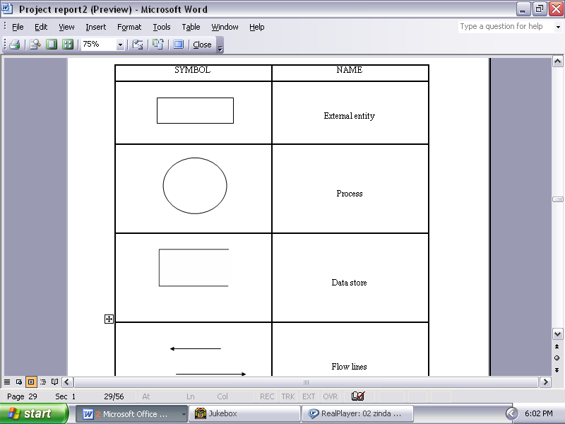

This are the various symbol used in data flow diagram. And we also had used this diagram to draw the data flow diagram.

2.5.1context level dfd
Interface

Generate Code for

Application
Program
Of VB
with
Code Information.dbf
Access database file
Visual
Basic
Editor

Vb
programmer

2.5.2 DFD-LEVEL-1
Select the product user wants
Sales record
Enter the record
Display employee record detail of employee
Acess the employee name
Bonus level
2.0
Give the bonus
Supervisor checks the work and then
Product
Cost 2.0
User
Enter
Access the product user has selected and then
Supervisor
Select the employee id and then
employee
Does the work
Display cost of product
value

2.6 CODING DETAILS:-
In this we have explained what is the way that we have provided for writng the code. In this we have done coding fully on visual basic language. We have used an ado connection for writing the code of the project. This ado is an active directx object it is basically used for making a connection with the database table and the vb language. This is very much useful also for the data access purpose. Also we have used an ms-access so with that it is easy to use the connection for the ado. Also in our project we have used the table called RS which is used for entering the value and also for the connectivity that is for storing the result of the two table. Also in our project there are various reserve keyword used for some database access purpose. Also we have used various comments in our project which will be useful for disabling some of the statements which might not be useful in our project. Hence there are various coding explanation which we have explained later in the complete explanation form. This is all about the coding part of the project.

2.7 SYSTEM TESTING:-

In this phase we have tested the project that we created. It basically sees the logical internals of the software and the logical externals of the software. It took around a week to complete this testing because after making the project we should to our guide who told to make several changes in the project. And also suggested to do the coding part properly. So after making all this we gave our guide to test the project.

2.8 MAINTENANCE:-

Software maintenance replies each of the preceding life cycle steps to an existing program. In maintenance part there are also we have done the various steps for maintaining it properly so that it does not require any extra maintaining part.

3 WHY V.B 6.0?

  - OVERVIEW OF VB LANGUAGE:-

Visual basic is a structured programming language and a complete application development tool for the MS WindowsXP operating system. It is an efficient interactive environment for designing forms. Due to its an integrated development environment(IDE), you can develop, run test & debug your application easily.

The imported feature that VB provides that it is Graphical User Interface Language. It relies on windows, iconic representation of entities, put down menus or pop-up-menus & pointing devices are now common place on personal computers & workstations. This type of interface demonstrates that the proverb “A picture is worth a thousand word” has not lost its truth. Now-a-day, users presented with a desktop filled with icons & programs which are helpful to user. Graphical User Interfaceare extremely helpful for the beginners. Therefore we decided to use Visual Basic with which we can develop Graphical User Interface based application for our project. Also the main motive behind using this language is that it is very user friendly and the student can easily interact with this system.

Also this language was taught to us in second year so we were having good hand in this language and so we decide to take visual basic as a forntend language. Also for studying this language we also reffered some of the books of it. The visual basic language can be easily written and there is no difficult to understand the code syntax because if one knows c and c++ then it will be very easy for him to study visual basic

3.2 several features of vb :-

  - multiple windows allowing different information to be displayed simultaneously on user screen , iconic information representation. Sometimes icon represents file & sometime it represents processes.

- Command selection via menus rather than a common language.

- A pointing device such as a mouse for selecting choices from menu of indicating items of interest in a window.

- This type of language in which during design time , you are able to see how your program will look during runtime.

- This is the great advantage over other programming language , because you are able to change and experiment with your design until you are satisfied with colors , sizes , images etc. which are included in your program.

- Visual Basic provides many readymade function & tool. This help us to get the output in graphical form.

- It provides the component MICROSOFT DATA REPORT DESIGNER VB 6.0 that is useful in creating the monthly report about the detail of any organization which we have used in our project to make the reports of the book.

- The code of the visual basic can easily written. And the code syntax is same as that of the any other software language. And this language code can be easily written by just seeing the books of the some visual basic.

- Also there is a facility of providing the ado connection facility with the help of the visual basic code. For this we have to enter the database value and the data table.

- In visual basic it is also very useful to create an MDI form. Also there are very easy ways to create an mdi form so then we will be very ways to design this form.

3.3) CONNECTING WITH MS-ACCESS:-

We have used MICROSOFT VISUAL BASIC 6.0 as front end and MICROSOFT ACCESS as backend. For connecting VB with MS-ACCESS we have used the component ADO by selecting the MICROSOFT ADO DATA CONTROL 6.0(OLEDB) property. Then we have created the database table in MS-ACCESS.

And then by using the ADODB properties and selecting MICROSOFT JET 4.0 OLEDB provider we have connected the created database to the VB. Also ms-access will be useful for entering the data in the database. This ms-access can also be useful for providing the ado connectivity with which we can add the value of the two table. This ms-access also create the third table automatically which will be useful for entering the table.

4) COMPLETE EXPALNATION

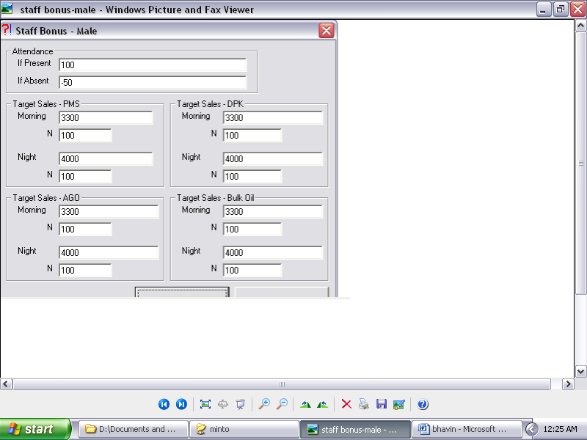

BONUS – MALE

Bonus is the main motive of every person earning in the world. This is an extra salary paid to the employee working in the world. This same procedure is repeated for our project . means here the employee will be given the bonus if he completes the work assigned to him was completed by him at the end of the week. There are several works to be done before getting the bonus. Also the bonus will be reducted 50rs if the employee was absent at that day.

This is the module of our project . it is used to calculate the bonus of the employee. Here also we can find that whether the employee is paid the bonus or not. But before giving the bonus we have to find that whether the target given to the employee was completed by him or not. If the target given to that employee was completed by him at the end of the week then he will be paid the bonus 100rs.but if he fails to achieve the target then the bonus given to him will not be given. Also at this time the supervisor can check whether the employee was present on that day. If he is present then he will be paid full 100rs bonus otherwise if he is absent then 50rs will be cutted from the employee bonus even though he achieve the target given to him.

This bonus will be given at the end of the month with his salary only. Also while calculating the bonus it is checked that in which shifts the employee was working. If he is working in night shift he will be given the bonus according to his work done that is achieving the target. And if he is working in morning shifts then he will be paid the bonus according to his morning target . This bonus is for also the female staff. For female staff the same procedure is repeated as the procedure given for the male staff.

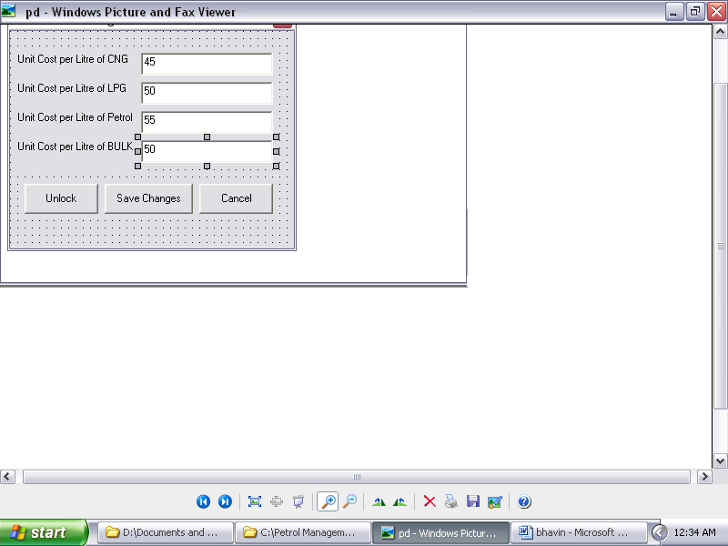

PRODUCT MANAGEMENT

This is the module which we added in our project which will be useful for the buyer to easily know what is the cost of each product and the cost of that product per liters. For this we have provided the password security so that the outsiders cannot change the cost of this product.

Here before opening it it will ask you for the password to enter. As soon as you enter the password it display the product management screen. It will display you the cost of each product. Here the cost will be changed as the cost for that product changes. Means the cost of petrol , oil , diesel changes in months or two months so this changes can be changed by us by login in to the product management form. This is the form which contain the main idea of the project. Means each one who comes to buy the product first sees the cost of that product and then he decide which one he should used. So it is the main form in our project.

This is the form which will be only viewed by the supervisor for making the changes in the form of it.

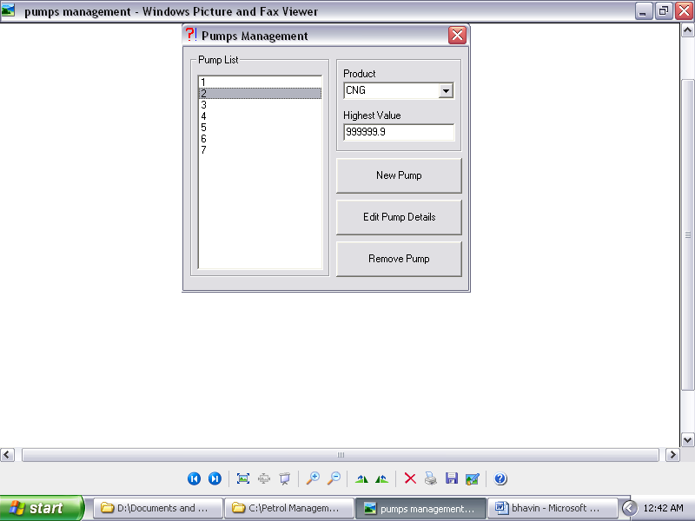

PUMPS MANAGEMENT

This is the pumps management form which will display the information about the pumps record. For this we have provided the password facility that means whenever you login you have to enter the user name and the password. This is done for the security purpose of the petrol pump.

Whenever you open this form it will display the password field in which you have to display the password and as you enter the correct password it will display you the pumps management form. This form contain the product name , pump list , highest value , new pump , edit pump , remove pump.

If the supervisor wants to know the final reading calculated by the employee then he can view that information just by selecting the pump-list button. As soon as you select this button it will display you the product name and the highest value calculated by that employee working on that form. This will display the different readings for different product and the employee might be the same because he might work for one pump on one day and on another day he will work for the another pump. So this will be automatically generated inside only.

Here we can also add the new pump name if some arises. Means if there is a new employee then the record for that employee can be created. We also have provide the edit option with which we can edit the information if the supervisor has entered some wrong information then he can edit it by clicking just edit button and he can change the information. Also there is a facility to delete the pump record from the pump list .suppose if some employee was working on pump1 and then he suddenly lives the job and some other employee comes on his place then he can remove the information of that employee who has left by deleting the record for that employee. And also he can add the record of that new employee by selecting the new pump option. Also the employee highest value will be calculated of that employee.

This is all about this form we have added in our project.

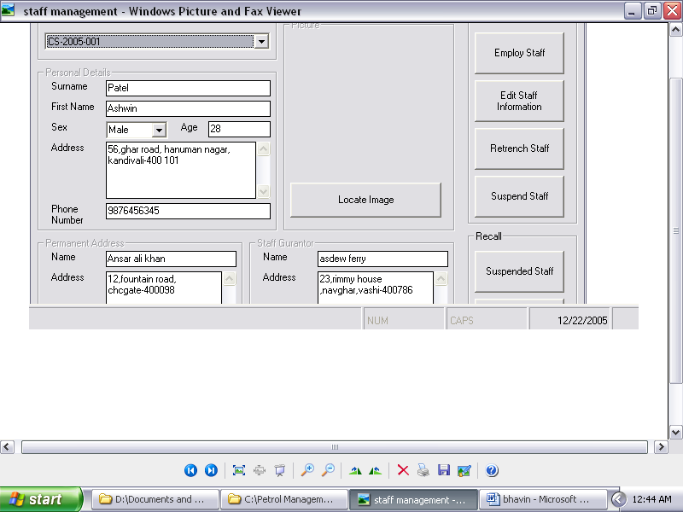

STAFF MANAGEMENT

This form will give us the information about staff. Here also we have provided the password facility so that any other employee cannot see the staff record of some other record. There are several options like staff id number , personal details , permanent address , staff guarantor , retrenched staff , suspend staff , edit staff information , employee staff. This are the various forms of our project.

First when you open this module it will ask you for the password field. Once you enter the password then it will display you the staff management form in which all the details about that staff is associated. If you want the information of some employee then you have to select the staff id number options which will display the id of the employee. You just select the id of that employee which you want and then it will display the information of that employee. It will display the first name , last name , surname. Also it will display the information like his age , sex , address , permanent address , staff guarantor. In permanent address it will display the native address of that employee. Also if you want to add some new employee then it can be done by selecting employee staff option. Then you fill all the information of that employee and click on save it will ask you for the employee id number and as soon as you enter the id number the record for that employee will be saved.

Also there is the facility to retrenched the staff record. If some employee has been removed from the pump hen his record will be deleted by selecting the retrenched staff record options. This will remove the record of that employee from the staff management record. Also if some employee has been suspended for some days then the information can be removed for some days and then it can be saved in this record called suspended information.

Also in our project we have included the facility of recalling the information of the employee which were retrenched and suspended. For doing this you have to select the retrenched button from recall staff information module. It will ask you for the id number for which staff you want to view the information just select his id number and then the information for that employee will be recalled. Also the same procedure is repeated for viewing the information about the employee which are suspended. You can also recall the instruction of that employee by selecting an option suspended staff. This will recall the information of the employee which are suspended. Also there is a facility of including the image of that employee if the supervisor wants to add .This is all about the staff management module. This is used for calculating the all records.

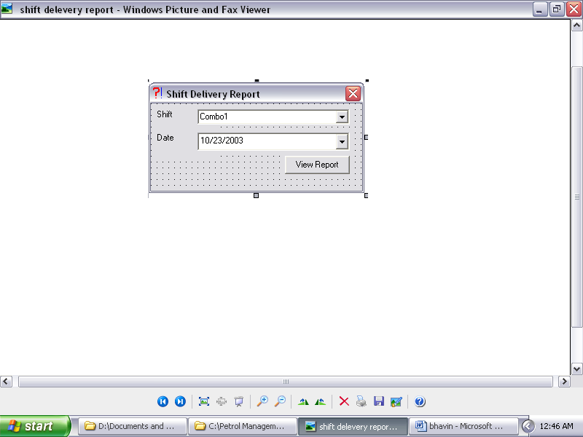

SHIFT DELEVERY REPORT

This is the module called the SHIFT DELEVERY REPORT which is used for calculating the report of the employee according to their shift. Here we have provided the password facility so that so that n any other cannot view the information about this except the supervisor of that pump. It has option like shifts and the date.

As soon you open this form it will ask you for the password and as you entered the correct password it will open you the form. First for viewing the information about it you select the shift of that employee and then select the date of that employee that is from where to where the date you want. And after selecting it click on view report it will display you the report of that employee. As soon you hit enter if there is a record found it will display a message that one record found in database and there if you click ok it will display the whole record of that employee like staff id , staff name , pump , initial reading , final reading , returned to tank , actual litres sold , amount , unit cost and reason for returning to the tank.

This all information like amount will display the amount colleted by that employee at the end of the day also we can find that in which shifts he was working. There also a form called initial reading and final reading which will display you the initial reading of that employee and also display the final reading collected by him at the end of the day. You can also view information like litres being sold by that employee at the end of the day. And what was the amount of petrol he was given at the beginning of the day. Also it displays the unit cost means the cost of the product sold per unit of litres. It will also display the employee id of that employee. Also we have provided the facility of finding a report of an employee that is an individual report an employee. In this you just have to enter the shifts and just select the date and then click on view report it will display the report of the individual employee in this you can view the report of the single employee only here there is no facility of including report of more than one employee.

This is all about this forms which we have included in our project. This calculation is done automatically from the database table which views the information of the employee. This is the table for viewing the report of the single employee as well as more than one employee.

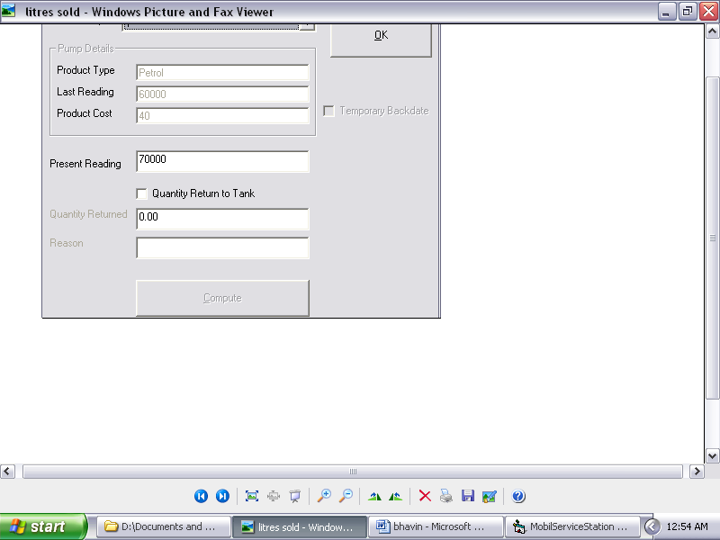

LITRES SOLD

This form name is LITRES SOLD. As by the name only you can conclude that what it will display. This is the form which displays information about the litres sold by an employee. Here we have provided the password facility so that none of the employee can see the information and also they cannot change the information if they want. This is only being viewed by the supervisor and the manager of the pump to view the information of the employee to find that what is the amount of petrol , oil , diesel is sold by an employee.

First when you enter the field it will ask you for the password and when you enter the password it will open the form litres sold. In this form it contain various option like select pump , pump detail , present reading , quantity returned , reason for returning the product. Here you have to select all the information if you want to view the information.

Here we have created a link between all the product if you enter the one value it will ask you to enter the second value. First when you select the pump it will display you the it will automatically display you the product type , last reading and the cost of that product. Then it will ask you to write the present reading and when you write the present reading it will ask you to write that whether you have returned any product or not if you have returned then just write the amount of quantity returned and also you have to write the reason for returning the product. If you have not returned the product then just click the compute option and then it will display the litres sold by an employee and the amount collected by that employee. And then when you click on OK button it will save the record of that employee. Also here the record will be saved to the on the particular employee pump number. Here also you can view the information about the target given to the employee was competed by employee or not if not then no target incentives will be given by them. That means no bonus will be given to that employee if no target is completed by it.

This is all about calculating the litres sold of the particular employee this all is done automatically by just one computer. In this it will display all the information related to it just by clicking one button compute it will automatically calculate the litres sold and the amount collected by them.

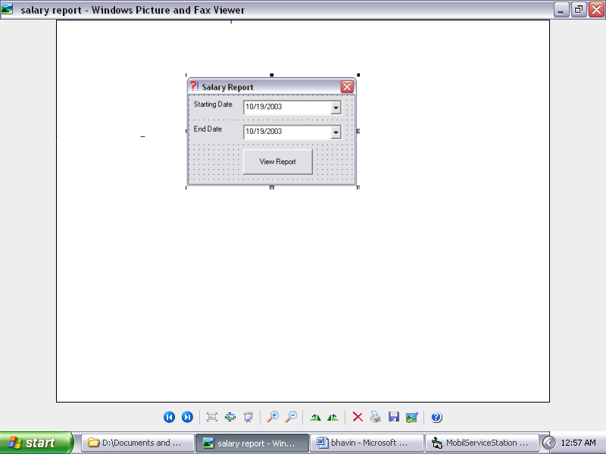

SALARY REPORT

This the form named SALARY REPORT this will display the name and salary of the employee. Besides this it ill also display the various information about the employee salary like his name , age , pump number , target and the amount calculated by it. It will also display that the number of times the employee is absent and the number of times he is present.

Here we have provided the password facility which will ask you for the password whenever you login in this form. And when once you enter the password it will open you the form salary report. This is used for viewing the information about the staff salary which means that will say how the salary is calculated and how the employee is paid. Before calculating the salary various procedure is followed by the supervisor they are as follow. Here first the supervisor will check whether the employee is present for whole month or not and also checks whether the employee is absent for any of the day or not. If the employee is absent then the total number of days he is absent that much amount of rupees will be reduced from his employee.

Also the supervisor checks whether the target given to that employee is completed or not if yes then he will be given the bonus. If the employee fails to achieve the target then he will not be given the bonus. Also the staff id number will be displayed in this field and also the total sales done by that employee will be calculated by that employee is done at the end of this day.

This all is done automatically by the computers only. The supervisor does all this thing so only the password will be given to the supervisor who will be calculating the salary of the employee. The supervisor will calculate the salary just by clicking some information and he don’t have to write all this information in the file and keep a risk of losing that information. Instead of this the record will be stored in just one computer and can be viewed whenever it is needed by the supervisor to check some information. This will not be shown to all the employee it will be only shown to that employee whose salary is being calculated.

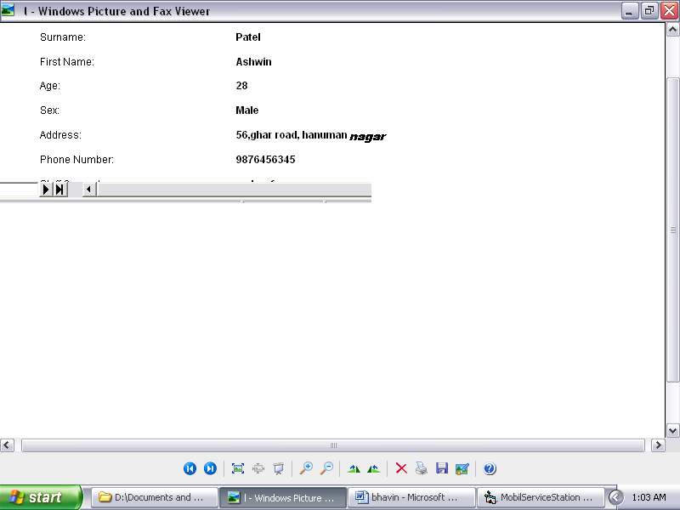

SELECT STAFF REPORT

This is the form called the SELECT STAFF REPORT . As by the name only you can see that it will calculate the staff report. Here we have provided the password facility means nobody else can access the information about the employee only the supervisor and the manager of the petrol pump can access this . here it has various option like staff name , staff address , staff guarantor , his joining-date and also it contain a view report button which views the information as soon as you click it after selecting a staff name.

Here when you enter the form it will ask you to enter the password and once you enter the password it will open up a select staff report screen. In this it contain information all about the staff. Here first you have to select the staff name for which you want to view the information and as soon as you select the staff name and then click view report it will display the report of that employee for which you wants. In this it will display the information like staff name , staff id , surname , first name , sex , permanent address , phone number.

This all is needed to keep the record of that employee so that at the time when you want to view a record you don’t have to search the record in the file instead of it the record can be easily found by just selecting the staff name and selecting the view report button. This will be easy for the supervisor because it will save the time of him in searching a record. So this will be very useful in petrol pumps .

This is necessary because if any of the employee is absent and the supervisor wants to call the employee for his work or wants to find out the reason why he is absent then he can just make a call to him and can find the information. This will be applied to all the employee but in this we can find the information of the single employee only not multiple employee information can be viewed in a single time. This can also be done by this but for this we have provided a link with staff report which will display the information that the staff record will display whenever the user wants it.

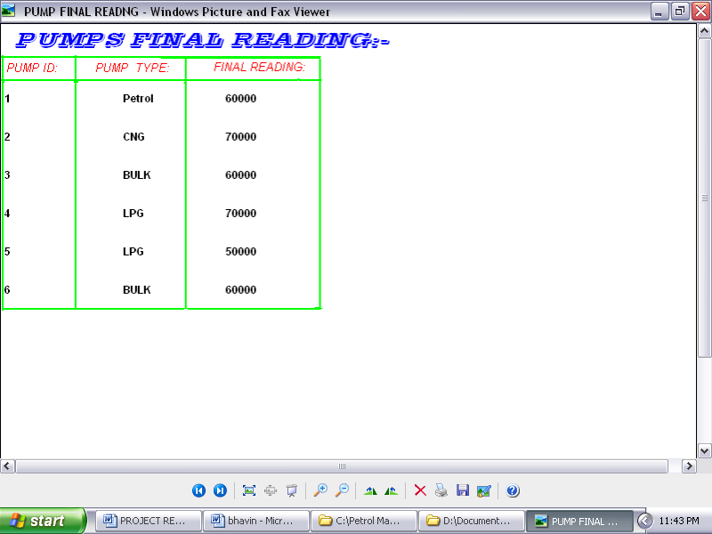

PUMPS FINAL READING

This is the form named pumps final reading. It is used for displaying the pumps final value. Here also we have provided the password facility. Means this for the security purpose. It contains various options like pump id , pump type , final reading. This all is connected to each other thru the database.

First when the user wants to access to this form then he has to enter the password for that field. As soon as you enter the password it will display you the pumps final reading screen. This will contain information about this pump. First the supervisor has to go to the report forms then there he will select the pumps final reading option. As soon as he select this option a screen appear showing his login form and when he enters the password he will be viewed a final readings screen in which all the pumps final reading will be showed

This means that it will display pump id and then it will display the name of the product that the employee was working and then it displays the final readings that is the amount calculated by the particular employee at the end of the day and also it displays the target assigned to that employee was completed by him at the end of the week. This final reading should be always greater then present reading. In this the same product might be available to the different employee. Though the product given to the two employee is same but the final reading will always be different then the other employee. It might be possible that some employee might be absent on some day so the final readings for that employee will be less means it will have zero final reading.

This is all about of automatically calculating the final reading of the particular employee. Here the supervisor also don’t have to write any information it will be displayed directly as you click on view report because this is one by the linking of ado with the ms-access. Hence this what this module contains.

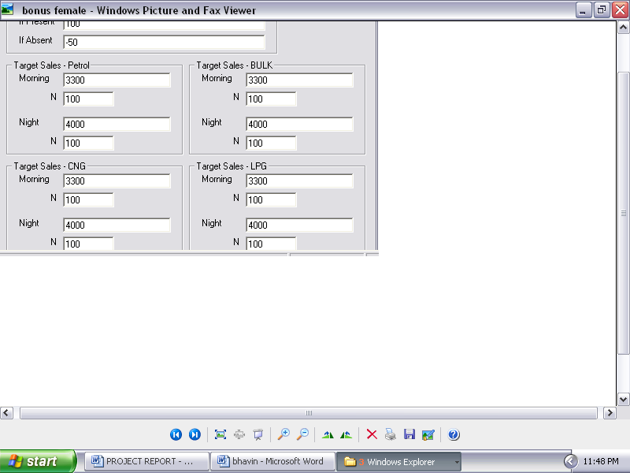

BONUS - FEMALE

Bonus is the main motive of every person earning in the world. This is an extra salary paid to the employee working in the world. This same procedure is repeated for our project . Means here the employee will be given the bonus if he completes the work assigned to him was completed by him at the end of the week. There are several works to be done before getting the bonus. Also the bonus will be reducted 50rs if the employee was absent at that day. This is bonus form of female

This is the module of our project. It is used to calculate the bonus of the employee. Here also we can find that whether the employee is paid the bonus or not. But before giving the bonus we have to find that whether the target given to the employee was completed by him or not. If the target given to that employee was completed by him at the end of the week then he will be paid the bonus 100rs.but if he fails to achieve the target then the bonus given to him will not be given. Also at this time the supervisor can check whether the employee was present on that day. If he is present then he will be paid full 100rs bonus otherwise if he is absent then 50rs will be cutted from the employee bonus even though he achieve the target given to him.

This bonus will be given at the end of the month with his salary only. Also while calculating the bonus it is checked that in which shifts the employee was working. If he is working in night shift he will be given the bonus according to his work done that is achieving the target. And if he is working in morning shifts then he will be paid the bonus according to his morning target. This bonus is for also the female staff. So this is the same procedure which is repeated in the bonus form of module. Here also they are given some target and they have to complete this work and then they are paid the bonus. So this is the main target but this is not for all pump only those pump where the female work.

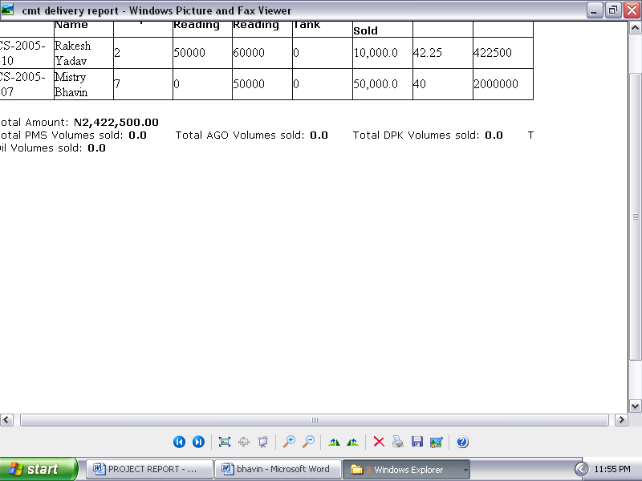

CUMULATIVE SHIFT DELEVERY REPORT

This is the form called CUMULATIVE SHIFT DELEVERY. It is basically a report generation which is used for generating a report of the employee. Here we have provided the password facility so that any other user cannot see this report or can make changes to this report. It can contain various option like shifts , date from starting and the end. This is very useful for easily calculating the report of the particular employee.

Here when you enter it will ask you for the password and when you enter the password it will check inside only whether the password is correct or not if yes then it will open you the report called cumulative shift delivery. This form is mainly used for finding the weekly report of the employee. Suppose in some pump the payment is done weekly so there the supervisor needs to keep the record of employee while giving the payment to check whether the employee is present whole week or not and also check whether the target given to him was completed at the end of the week so accordingly he will be paid the bonus for that extra work.

After then for viewing the report the user have to select the employee name from different table and from then as he select the name from this table he has to select the shifts for which he is working and then he has to select the date and as soon he click on the view report it will display him the report of that employee in which it will display him the staff id staff name amount collected and many more. This is for only one employee if the supervisor want to view record for more than one employee than also it is possible by the help of this report here just the supervisor has to select the shifts and the date and then the report if are present then it will give you the message that there are 5 records or more than that record are present and it will display him the report of that employees which he was watching for.

So this is what this module says about how it is easy to find report of the employee with the help of just one computer. Here there is no need of maintaining the record in the file it can be automatically created in the database and can be displayed whenever we want for this just we have to select some option and the report is automatically generated. This all will save the time of the supervisor and he will not be confuse in finding the record.

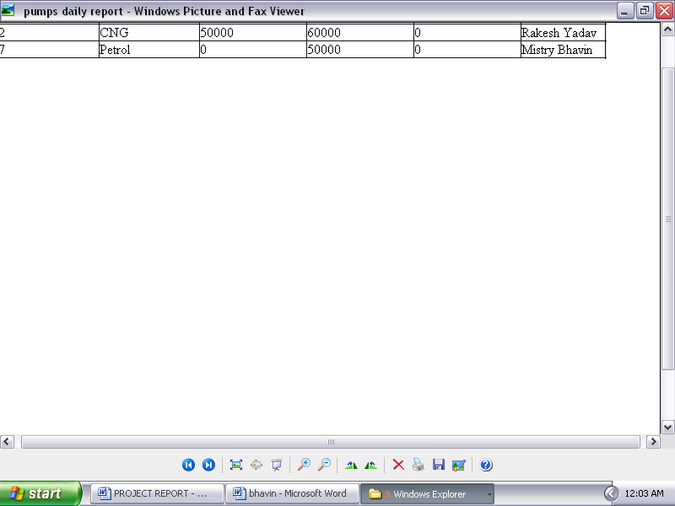

PUMPS DAILY REPORT

This is the next module named PUMPS DAILY REPORT this is use for viewing the report of the employee. Here we have provided the password facility so that no employee can view the information about this. This is only for the supervisor because this can view him the daily report of the employee pumps what he has sold what is the expenditure of that employee. This has various options like shifts to select the shift of the employee , date to view the report from which date to what date the report the supervisor wants and the view report button.

Here when the user enter the field it has to enter the password and as soon as he enter the password it checks whether the password is correct or not if the password is correct then he can view the information. If the supervisor wants to view the information of the employee working on the pump no 4 what is his work on the end of the day. Then for that he has to select the employee number and then he has to select the shifts for which that employee was working and the date from which date to what date the supervisor wants the report and then he has to click on the view report button and then it will display him the report of that employee.

In this report it will display him the pump id , pump type , initial reading , final reading , returned to tank , staff name. This all are the contents that will display in the report. The staff name will display the employee name who was present on the pump of which the supervisor wants to view the information. The final reading will display the final value seen on the employee pump on which he was working. The pump type will display him the name of the product which the employee was selling. That is whether he was selling the cng or petrol. And the initial reading will display him the initial value that was calculated before the starting of the day and the final value will display him the final value value calculated at the end of the day.

Then there is a option called pump id this we have provided as a id of a particular employee through which they can be identified uniquely even though the name is different. This we have declared as a primary key in our ms-access and provided it a ADO connection through which we can view the contents inside it and this ID will be different for different person no two employee will have a same ID. The ID will be repeated to the employee who has been replaced for the other employee means that the I of the employee can be given to the employee who has join in place of that employee.

This is all we have added in our project and has been explained by us in our project report.

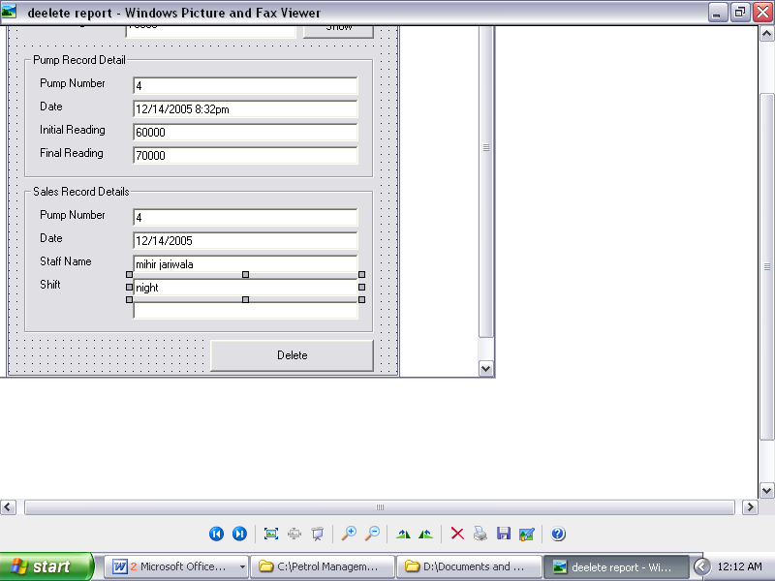

DELETE REPORT

This form is about deleting record. This will be use to delete the record of the employee. Here we have provided the password facility so that no other employee can delete the record of any other employee. This is only for the supervisor to delete the record of the employee. This will be done if the employee has left the petrol pump. It has various option like select pump , final reading , initial reading , pump number , date and also it has sales record form in which it has option like pump no , date , shifts , name.

Here if the supervisor has to open the form then he has to enter the password and if the password if correct then it will open a form called MASTER DELETE. This will delete the record of the employee. Before deleting the record the supervisor has to enter the various value like firstly it has to select the pump that is whether he was selling cng , gas , petrol , bulk ands then he click on show button this will display him the whole information like it will display him the last value of that employee that was collected by him at the end of the day before he was closing his job. Then there is a pump record detail form in this it will display him the number of the employee pump in which pump number he was working and the date for which he was working. After then it will display him the initial reading of that employee that is currently seen in his pump and also the last reading that is calculated by him at the end of the day.

Then there is a form called sales record detail which will be useful for viewing the detail of the sales work of the employee. In this it will display the pump number and the date as above form only there is a change in it that it will display the staff name that is the name of the employee who is working on that pump and the shift of that employee whether he has worked in morning shift or night shift. After viewing all these information then we have provided the connectivity to the ado which will be useful for storing all this information if the user wants. This connectivity is provided so that if the record is deleted then the information is stored in the ado table so if the supervisor wants to access the information then it can view that information. Then finally if all the information is over then if the supervisor wants to delete the record it has to just click on the delete button then it will delete the record of that employee. This record will be permanently deleted from the supervisor pump list but it will not delete the information permanently it will save the record because it might be useful whenever necessary.

Then there is all this facility that we have provided for deleting the record. And all this we have explained in our project report. And this is all about our form delete.

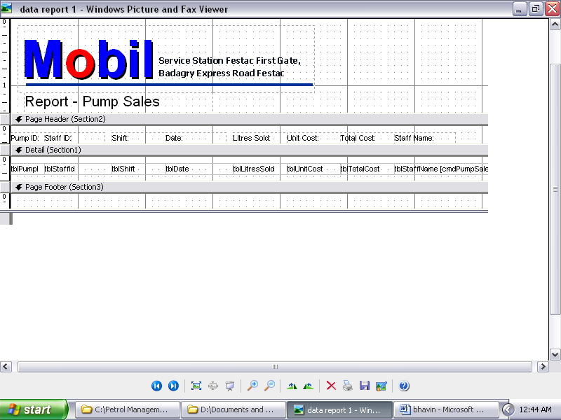

DATA REPOTR 1

This a module called report. In this we have provided the information about the report . here we also have provided the password facility so that any other user cannot access the information this can be only viewed by the supervisor only. No employee can access this report. Here it has various option like date , litres sold , shifts and various other reports are generated by this form.

Here before opening this form the supervisor has to enter the password. As soon as the password is entered it checks whether the password is correct or not and if the password is correct it ill open him the form called report pump sales. Also it contain information like the report of his shifts that is in which shifts he is working. The employee might be working in a night shift or in morning shifts. Also the report of his product which he is selling is been calculated in this report. Also the staff id of that person is been seen. This id is a unique for only a single employee. This id will be not same for all the employee. This is provided so that the supervisor finds it easy to calculate the record of the employee. Also the staff name is provided because the supervisor wants to calculate the record then it can be calculated easily. Also the final reading and the initial reading of the employee can be calculated in this report. Also the total cost of the employee can be calculated by the supervisor easily without maintaining the record. This total cost of the employee can be calculated just by viewing some of the information in the table and thus table has provided the connectivity to the ado. There is also a facility to calculate the litres sold of the employee. Means if the user wants to calculate the amount of the product sold by the employee at the end of the day then he can view that information in this report.

Also there is a facility to view the report of the employee called table unit cost in which the per unit cost of the employee can be calculated and this can be viewed the report of the employee. This will be very useful for the supervisor because if he wants to see the report of the employee that what is his sell per unit cost then it can be calculated by the supervisor just by clicking the information as given in the report.

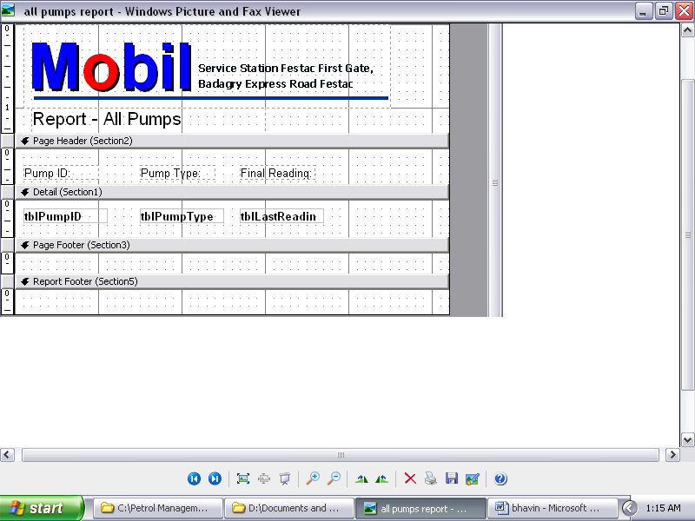

ALL PUMPS REPORT

This is a form called the report which will be useful for creating the pumps report. Here we have designed the form with the help of the mdi form. This report has database connectivity which will be useful for entering the data in the database table. Here we have provided the password facility so that no employee can open the form. This report can be only opened by the supervisor.

Before entering the report form the supervisor has to enter the password as soon as he enters the password he will wait for sometime and as soon the password is verified then if the password is correct then it will open the report. It has various option like page header section , page footer section , detail section.

The page header section contain option like pump id this is a primary key of the project which will be useful for giving each employee a different id. So that if there are two employee with same name then the supervisor will not find it difficult to calculate the report of the employee.

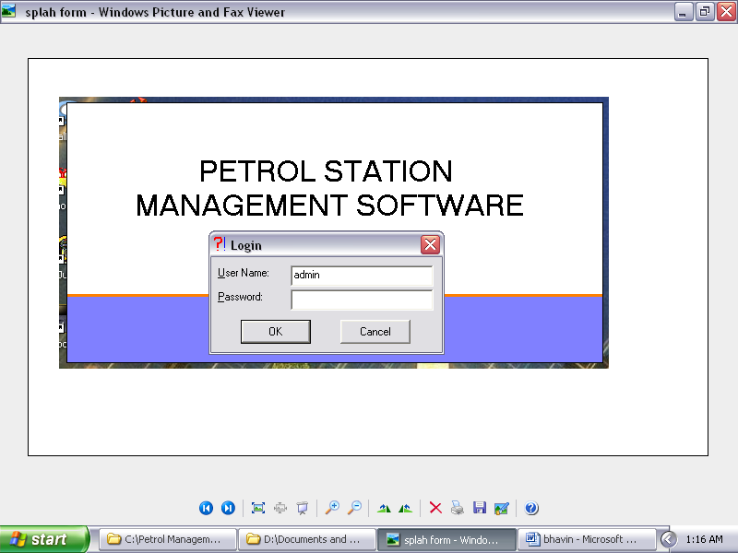

SPLASH LOGIN FORM

This is the main login form. That is the splash screen that we have provided in the project. This screen will be opened at the time when you will first time open the project exe file. Here there are login name and password facility. This form will be the only form of the viewing only.

Here as soon as you run the project it will ask you for the login name and password. In this screen we have provided the ado connectivity so that it will be useful only if the user wants to set it on the screen for sometimes. Here we have set the timer so that for that particular timing the screen will be viewed for the uaser so that it can be viewed and can be easily splash the screen. This form also has the advantage that if the person wants to make his project more deginable then it has to use this splash screen shot.

Here we have no coding part only we have designed the form in ado. There is an image part that we have used and it is useful entering the desing only and in the properties we have set the timer only so that it can be not viewed at the whole time until you close the project. Also for password we have provided the facility that if the user wants to change the passwords then he can change the password but this can be done only by those user who knows the old password.

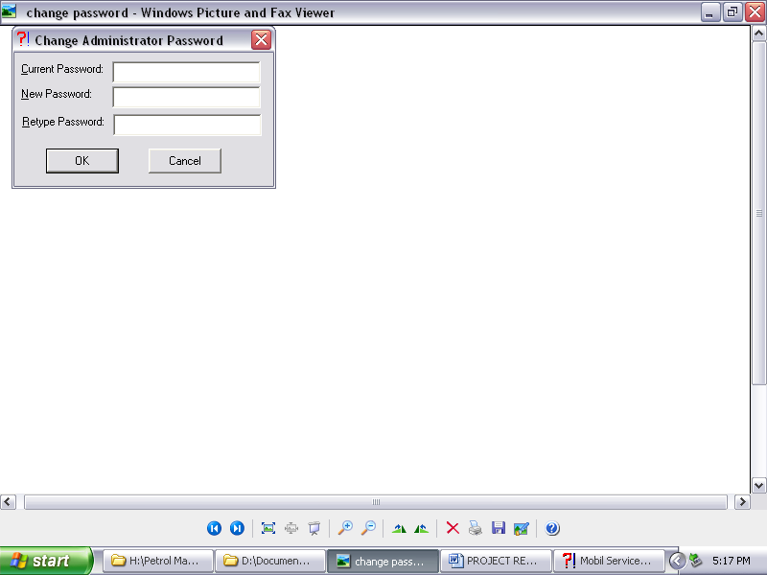

CHANGE PASSWORD

5)ADVANTAGES:-

As each project has its advantages other-wise without advantages it will not be useful. Because in now-a-days company are growing in rapid form because of there several new forms. Also in our country there are several industries which are getting developed by the software companies so for that we have to use such explanation. The motive behind having advantage in our project is that if we want to get selected our project in industries then there should be some features difffernt then there are in other projects. Also there are several advantages in our project like:-

- It is very user friendly:- This means that these project can be handled without any much distortion. Also there is no need to have to study this software and then to use it.

- Cost effectiveness:- This project is very cheaper as they don’t require the hardware equipment. Means this project can be completed in the low cast. Here you have to only use the software language like vb and ms-access.

- Easy to backup:- The back up of this project is very easy to handle. Also the record if deleted by mistake be deleted permanently it will store in the database files.

- Data security:- In our project we have provided the password facility so that each module can have their data security. Here also the report module which cannot be opened without the password so for that we have provided the security purpose.

- Also in our project the coding part can be easily understand by the other person. Also the coding part of our project is totally written in visual basic language because it is very user friendly.

- The form of our project is also designed in full MDI form. This designing is useful for identifying the which form is useful.

- Finally the main advantage is that it can be used in any pump with only one pc and there is no need of any type of the extra hardware requirements.

6 FUTURE EXPANSION:-

As all the project have their future expansion. All the projects may be changed in the future by the other person. In the same way we also have our project future expansion. In future somebody might buy this project. Also some might create a better project than this. And this project is easy to use. Means that somebody might add some additional features to these projects and can expand these project. But these project is not yet created in any of the college so we decided to make these project.

Also in future some industries might be interested in buying this project. And also we will be in future we will try to make these project more interesting by adding some features in it.

Also this is developed in visual basic language but in future it can be developed in some other language but it is very easy to develop in this language as it is user friendly. Also in this we have provided the ado connection so somebody in future if expanding the project then he might use some other connectivity.

